JAVA PROGRAMMING

Find the largest element and smallest element in the Array
import java.util.Scanner;
public class Main{
public static void main(String[] args) {
Scanner sc = new Scanner(System.in);
System.out.print("Enter the number of elements in the array: ");
int n = sc.nextInt();
int[] arr = new int[n];
System.out.print("Enter the elements of the array: ");
for (int i = 0; i < n; i++) {
arr[i] = sc.nextInt();
}
int max = arr[0];
int min = arr[0];
for (int i = 1; i < n; i++) {
if (arr[i] > max) {
max = arr[i];
}
if (arr[i] < min) {
min = arr[i];
}
}
System.out.println("The largest element in the array is: " + max);
System.out.println("The smallest element in the array is: " + min);
}
}

Find the sum of the positive elements in the Array

import java.util.Scanner;
public class Main{
public static void main(String[] args) {
Scanner sc = new Scanner(System.in);
int sum = 0;
System.out.print("Enter the number of elements in the array: ");
int n = sc.nextInt();
int[] arr = new int[n];
System.out.print("Enter the elements of the array: ");
for (int i = 0; i < n; i++) {
arr[i] = sc.nextInt();
if (arr[i] > 0) {
sum += arr[i];
}
}
System.out.print("The sum of the positive elements in the array is: " + sum);
}
}
Sum of two Array problem
import java.util.Scanner;
public class Main{
public static void main(String[] args) {
Scanner sc = new Scanner(System.in);
System.out.print("Enter the number of elements in the array: ");
int n = sc.nextInt();
int[] arr = new int[n];
System.out.print("Enter the elements of the array: ");
for (int i = 0; i < n; i++) {
arr[i] = sc.nextInt();
}
System.out.print("Enter the target sum: ");
int target = sc.nextInt();
for (int i = 0; i < n; i++) {
for (int j = i + 1; j < n; j++) {
if (arr[i] + arr[j] == target) {
System.out.println("The two numbers that add up to " + target + " are: " + arr[i] + " and " + arr[j]);
}
}
}
}
}

Odd to Even and Even to Odd count
import java.util.Scanner;
public class Main{
public static void main(String[] args) {
Scanner sc = new Scanner(System.in);
int oddToEvenCount = 0;
int evenToOddCount = 0;
System.out.print("Enter the number of elements in the array: ");
int n = sc.nextInt();
int[] arr = new int[n];
System.out.print("Enter the elements of the array: ");
for (int i = 0; i < n; i++) {
arr[i] = sc.nextInt();
}
for (int i = 0; i < n - 1; i++) {
if (arr[i] % 2 != 0 && arr[i + 1] % 2 == 0) {
oddToEvenCount++;
}
if (arr[i] % 2 == 0 && arr[i + 1] % 2 != 0) {
evenToOddCount++;
}}
System.out.println("The count of odd to even transitions is: " + oddToEvenCount);
System.out.println("The count of even to odd transitions is: " + evenToOddCount);
}}
Search an element in the Array

import java.util.Scanner;
public class Main{
public static void main(String []args){
Scanner sc = new Scanner(System.in);
System.out.print("Enter the number of elements in the array: ");
int n = sc.nextInt();
int[] arr = new int[n];
System.out.print("Enter the elements of the array: ");
for (int i = 0; i < n; i++) {
arr[i] = sc.nextInt();
}
System.out.print("Enter the element to search: ");
int target = sc.nextInt();
int count = 0;
for (int i = 0; i < n; i++) {
if (arr[i] == target) {
count++;
} }
if (count > 0) {
System.out.println("The element " + target + " is present in the array and it occurs " + count + " times.");
} else {
System.out.println("The element " + target + " is not present in the array.");
}}}
Reverse an Array
import java.util.Scanner;
public class Main{
public static void main(String[] args) {
Scanner sc = new Scanner(System.in);
System.out.print("Enter the number of elements in the array: ");
int n = sc.nextInt();
int[] arr = new int[n];
System.out.print("Enter the elements of the array: ");
for (int i = 0; i < n; i++)
{
arr[i] = sc.nextInt();
}
System.out.println("\nThe reversed array is: ");
for (int i = n - 1; i >= 0; i--)
{
System.out.print(arr[i] + " ");
}
}
}

Frequency of elements in the Array
import java.util.Scanner;
public class Main{
public static void main(String[] args) {
Scanner sc = new Scanner(System.in);
System.out.print("Enter the number of elements in the array: ");
int n = sc.nextInt();
int[] arr = new int[n];
System.out.print("Enter the elements of the array: ");
for (int i = 0; i < n; i++) {
arr[i] = sc.nextInt();
}
System.out.println("\nThe frequency of elements in the array is: ");
for (int i = 0; i < n; i++) {
int count = 1;
for (int j = i + 1; j < n; j++) {
if (arr[i] == arr[j]) {
count++;
arr[j] = Integer.MIN_VALUE; // Mark as counted
}
}
if (arr[i] != Integer.MIN_VALUE) {
System.out.println(arr[i] + " occurs " + count + " times.");
}
}
}}
Remove duplicates from the Array
import java.util.Scanner;
public class Main{
public static void main(String[] args) {
Scanner sc = new Scanner(System.in);
System.out.print("Enter the number of elements in the array: ");
int n = sc.nextInt();
int[] arr = new int[n];
System.out.print("Enter the elements of the array: ");
for (int i = 0; i < n; i++) {
arr[i] = sc.nextInt();
}
System.out.println("\nThe array after removing duplicates is: ");
for (int i = 0; i < n; i++) {
int count = 0;
for (int j = 0; j < i; j++) {
if (arr[i] == arr[j]) {
count++;
}
}
if (count == 0) {
System.out.print(arr[i] + " ");
}
}
}
}

Adjacent stick Game
import java.util.*;
public class Main{
public static void main(String [] args){
Scanner sc=new Scanner(System.in);
System.out.print("Enter Size of the array1: ");
int n1=sc.nextInt();
System.out.print("Enter array1 values: ");
int arr1[]=new int[n1];
for(int i=0;i<n1;i++)
{
arr1[i]=sc.nextInt();
}
System.out.print("Enter Size of the array2: ");
int n2=sc.nextInt();
System.out.print("Enter array2 values: ");
int arr2[]=new int[n1];
for(int i=0;i<n2;i++)
{
arr2[i]=sc.nextInt();
}
int mergedArr[]=new int[n1+n2];
for(int i=0;i<n1;i++)
{
mergedArr[i]=arr1[i];
}
for(int i=0;i<n2;i++)
{
mergedArr[n1+i]=arr2[i];
}
System.out.println("Merged array: ");
for(int x:mergedArr)
System.out.print(x+" ");
}
}

Find the array elements which sum is the Target

import java.util.*;
public class Main{
public static void main(String [] args){
Scanner sc=new Scanner(System.in);
System.out.print("Enter Size of the array: ");
int n=sc.nextInt();
System.out.print("Enter array values: ");
int arr[]=new int[n];
for(int i=0;i<n;i++)
arr[i]=sc.nextInt();
System.out.print("Enter the target sum: ");
int target=sc.nextInt();
for(int i=0;i<n;i++){
for(int j=i+1;j<n;j++){
if(arr[i]+arr[j]==target){
System.out.println("The two numbers that add up to " + target + " are: " + arr[i] + " and " + arr[j]);
}
}
}
}
}

You are given an integer array a of size n which represents houses from ith house you can go directly to (i+a[i])th house.if it is present.your task is to find the minimum number of jumps required to reach the last house from the first house.if it is not possible to reach the last house return -1
import java.util.*;
public class Main{
public static void main(String [] args){
Scanner sc=new Scanner(System.in);
System.out.print("Enter Size of the array: ");
int n=sc.nextInt();
System.out.print("Enter array values: ");
int arr[]=new int[n];
for(int i=0;i<n;i++)
arr[i]=sc.nextInt();
int visited=0;
int currentEnd=0;
int farthest=0;
for(int i=0;i<n-1;i++){
farthest=Math.max(farthest,i+arr[i]);
if(i==currentEnd){
visited++;
currentEnd=farthest;
if(currentEnd>=n-1)
break;
}
}
if(currentEnd<n-1)
System.out.println(-1);
else
System.out.println(visited);
}
}

By this code Print A and B in a single Line :

import java.util.Scanner;
public class Main {
public static void main(String[] args) {
Scanner sc = new Scanner(System.in);
System.out.print("Enter two long integers: ");
long a = sc.nextLong();
long b = sc.nextLong();
System.out.println(a + " " + b);
}
}

Round of two decimal places using Float
import java.util.Scanner;
public class Main {
public static void main(String[] args) {
Scanner sc = new Scanner(System.in);
System.out.print("Enter a decimal number: ");
double num = sc.nextDouble();
System.out.printf("Rounded number: %.2f", num);
}
}
Round-off a number to the nearest integer using Math ceil and floor
import java.util.Scanner;
public class Main {
public static void main(String[] args) {
Scanner sc = new Scanner(System.in);
System.out.print("Enter a decimal number: ");
double num = sc.nextDouble();
System.out.println("Rounded up (ceiling): " + Math.ceil(num));
System.out.println("Rounded down (floor): " + Math.floor(num));
System.out.println("Rounded to nearest integer: " + (int)(num));
}
}

BY THE GIVEN ARRAY TAKE 2 NO TO SUM AND GET SAME OUTPUT PAIR
import java.util.*;
public class Main {
public static void main(String[] args) {
Scanner sc = new Scanner(System.in);
int n = sc.nextInt();
int[] a = new int[n];

for (int i = 0; i < n; i++) {
a[i] = sc.nextInt();
}
int t = sc.nextInt();
Arrays.sort(a);
int l = 0;
int r = n-1;
int s = a[l]+a[r];
while(l < r){
if(s==t){
System.out.print("("+a[l]+","+a[r]+")");
l++;
r--;
}
else if(s<t){
l++;
}
else{
r--;
}
}
}
}

BY THE GIVEN ARRAY TAKE 3 NO TO SUM AND GET SAME OUTPUT PAIR

import java.util.Scanner;
public class Main {
public static void main(String[] args) {
Scanner sc = new Scanner(System.in);
int n = sc.nextInt();
int[] a1 = new int[n];

for (int i = 0; i < n; i++) {
a1[i] = sc.nextInt();
}
int t = sc.nextInt();
for(int i=0;i<n;i++){
for(int j=i+1;j<n;j++){
for(int k=j+1;k<n;k++){
if(a1[i]+a1[j]+a1[k]==t){
System.out.print("("+a1[i]+","+a1[j]+","+a1[k]+")");
}
}
}
}
}
}

MATH FUNCTIONS

MATH.ABS - NEGATIVE TO POSITIVE
MATH.SQRT - GIVE THE SQUARE ROOT VALUE
MATH.POW(2,3)-IT TAKE THE VALUE OF 2^3
MATH.MAX-FIND THE MAXIMUM NUMBER
MATH.MIN - FIND THE MINIMUM NUMBER
MATH.CEIL – ROUND THE DECIMAL TO WHOLE INTEGER
MATH.FLOOR - ROUND OFF THE LOWEST VALUE
MATH.ROUND - ROUND THE VALUES

ADD TWO ARRAY WITH THE EACH INDEX AND GIVE THE OUTPUT

import java.util.*;
public class Main {
public static void main(String[] args) {
Scanner sc = new Scanner(System.in);

int a = sc.nextInt();
int[] a1 = new int[a];

for (int i = 0; i < a; i++) {
a1[i] = sc.nextInt();
}
int b = sc.nextInt();
int[] a2 = new int[b];

for (int i = 0; i < b; i++) {
a2[i] = sc.nextInt();
}

int[] a3=new int[a];
for(int i=0;i<a;i++){
a3[i]=a1[i]+a2[i];
}
Arrays.sort(a3);
for(int i=0;i<a;i++){
System.out.print(a3[i]+" ");
}
}
}

Addition of two different size arrays element wise
import java.util.*;
public class Main{
public static void main(String[] args) {
Scanner sc=new Scanner(System.in);
System.out.print("Enter size of array1: ");
int n1=sc.nextInt();
int a[]=new int[n1];
System.out.print("Enter array1 values: ");
for(int i=0;i<n1;i++)
a[i]=sc.nextInt();
System.out.print("Enter size of array2: ");
int n2=sc.nextInt();
int b[]=new int[n2];
System.out.print("Enter array2 values: ");
for(int i=0;i<n2;i++)
b[i]=sc.nextInt();
int maxSize=Math.max(n1, n2);
int c[]=new int[maxSize];
System.out.print("The result array: ");
for(int i=0;i<maxSize;i++){
int valA=(i<n1)?a[i]:0;
int valB=(i<n2)?b[i]:0;
c[i]=valA+valB;
System.out.print(c[i]+" ");
}
}
}
Shift zeros to the end of the Array
import java.util.*;
public class Main{
public static void main(String [] args){
Scanner sc=new Scanner(System.in);
System.out.print("Enter array size: ");
int n=sc.nextInt();
int a[]=new int[n];
System.out.print("Enter array values: ");
for(int i=0;i<n;a[i]=sc.nextInt(),i++);
for(int i=0;i<n;i++){
if(a[i]!=0){
System.out.print(a[i]+" ");
}
}
for(int i=0;i<n;i++){
if(a[i]==0){
System.out.print(a[i]+" ");
}
}

}
}

Convert upper to lower using ternary operator
import java.util.*;
public class Main{
public static void main(String []args){
Scanner sc=new Scanner(System.in);
System.out.print("Enter a character: ");
char a=sc.next().charAt(0);
int no=(int)a;
System.out.println(no>96?(char)(no-32):(char)(no+32));
}
}
Palindrome string
import java.util.*;
public class Main{
public static void main(String[] args) {
Scanner sc=new Scanner(System.in);
System.out.println("Enter a string: ");
String org=sc.next();
String rev="";
for(int i=org.length()-1;i>=0;i--)
rev+=org.charAt(i);
System.out.println(org.equalsIgnoreCase(rev)?org+ " is a palindrome":org+" is not a palindrome");
}
}

TO GET THE ASCII VALUE NUMBER

import java.util.*;
public interface Main {
public static void main(String[] args) {
Scanner sc=new Scanner(System.in);
System.out.print("Enter the character: ");
char a=sc.next().charAt(0);
System.out.println("ASCII value of "+a+" is "+(int)a);
}
}
Rating app Problem
import java.util.*;
public class Main{
public static void main(String[] args) {
Scanner sc=new Scanner(System.in);
int rating[]=new int[5];
int sum=0;
for(int i=0;i<5;i++){
System.out.print("Enter rating (1-5) of the product"+(i+1)+": ");
rating[i]=sc.nextInt();
while(rating[i]<=0||rating[i]>5){
System.out.println("Invalid rating! Rate between(0-5)");
System.out.print("Enter rating (1-5) of the product"+(i+1)+": ");
rating[i]=sc.nextInt();
}
}
for(int x:rating){
sum+=x;
}
System.out.println("Average rating: "+(float)sum/5);
System.out.println((float)sum/5>3.8?"Discount available!!":"No discount! Try next time.");
}
}

Number of vowels
import java.util.Scanner;
public class Main {
public static void main(String[] args) {
Scanner sc = new Scanner(System.in);
System.out.print("Enter a word: ");
String word = sc.nextLine().toLowerCase();
int n = word.length();
int vc =0;
int cc = 0;
for(int i=0; i<n; i++){
if((word.charAt(i) == 'a')||
(word.charAt(i) == 'e') ||
(word.charAt(i)== 'i') ||
(word.charAt(i) == 'o') ||
(word.charAt(i)== 'u')){
vc++;
System.out.println(word.charAt(i));
}else{
cc++;
}
}
System.out.println("Number of vowels: "+ vc);
System.out.println("Consonants count: "+cc);

}
}
Butterfly pattern
import java.util.Scanner;
public class Main{
public static void main(String[] args) {
Scanner sc = new Scanner(System.in);
System.out.print("Enter the number of rows: ");
int n = sc.nextInt();
for (int i = 1; i <= n; i++) {
for (int j = 1; j <= i; j++) {
System.out.print("* ");
}
for (int j = 1; j <= 2 * (n - i); j++) {
System.out.print(" ");
}
for (int j = 1; j <= i; j++) {
System.out.print("* ");
}
System.out.println();
}
for (int i = n; i >= 1; i--) {
for (int j = 1; j <= i; j++) {
System.out.print("* ");
}
for (int j = 1; j <= 2 * (n - i); j++) {
System.out.print(" ");
}
for (int j = 1; j <= i; j++) {
System.out.print("* ");
}
System.out.println();
}
}
}
Problem Statement: Given boolean 2D matrix , find the number of islands. A group of connected 1s form an island. For example, the below matrix contains 5 islands.
import java.util.*;
public class Main{
public static void main(String[] args) {
Scanner sc=new Scanner(System.in);
System.out.print("Enter number of rows: ");
int m=sc.nextInt();
System.out.print("Enter number of columns: ");
int n=sc.nextInt();
int[][] matrix=new int[m][n];
System.out.println("Enter the matrix values (0 or 1): ");
for(int i=0;i<m;i++){
for(int j=0;j<n;j++){
matrix[i][j]=sc.nextInt();
}
}
int count=0;
for(int i=0;i<m;i++){
for(int j=0;j<n;j++){
if(matrix[i][j]==1){
count++;
dfs(matrix,i,j,m,n);
}
}
}
System.out.println("Number of islands: "+count);
}
public static void dfs(int[][] matrix,int i,int j,int m,int n){
if(i<0||i>=m||j<0||j>=n||matrix[i][j]==0){
return;
}
matrix[i][j]=0; // Mark as visited
dfs(matrix,i+1,j,m,n); // Down
dfs(matrix,i-1,j,m,n); // Up
dfs(matrix,i,j+1,m,n); // Right
dfs(matrix,i,j-1,m,n); // Left
dfs(matrix,i+1,j+1,m,n); // Down-Right
dfs(matrix,i+1,j-1,m,n); // Down-Left
dfs(matrix,i-1,j+1,m,n); // Up-Right
dfs(matrix,i-1,j-1,m,n); // Up-Left
}
}
Frequency of character
import java.util.*;
public class Basic{
public static void main(String[] args){
Scanner sc = new Scanner(System.in);
System.out.println("Enter a string:");
String a = sc.nextLine().toLowerCase();
int[] arr = new int[26];
for (int i = 0; i < a.length(); i++) {
char ch = a.charAt(i);
if (ch >= 'a' && ch <= 'z') {
arr[ch - 'a']++;
}
}
System.out.println("Character\tFrequency");
for (int i = 0; i < 26; i++) {
if (arr[i] > 0) {
System.out.println((char) (i + 'a') + "\t\t" + arr[i]);
}
}
}
}
Anagram Problem
import java.util.Arrays;
import java.util.Scanner;

public class Main {
public static void main(String[] args) {
Scanner sc = new Scanner(System.in);

System.out.print("Enter first string: ");
String str1 = sc.nextLine().replaceAll("\\s", "").toLowerCase();

System.out.print("Enter second string: ");
String str2 = sc.nextLine().replaceAll("\\s", "").toLowerCase();

char[] arr1 = str1.toCharArray();
char[] arr2 = str2.toCharArray();

Arrays.sort(arr1);
Arrays.sort(arr2);

if (Arrays.equals(arr1, arr2)) {
System.out.println("Strings are Anagrams");
} else {
System.out.println("Strings are Not Anagrams");
}
}
}
COLLECTIONS:
- Java collection frame work is a set of classes and Interfaces that provide redimade Data Structures To Store And Manipulate Group Of Object Efficiently.
- Java provide collection interface like list,set,map,with redimates classes such as arraylist,Hastset,Hashmap,priorityqueue so you dont have to write data handling code from scratch
- The collection frame work include productivity by making a code reusable,maintanable and faster to develope

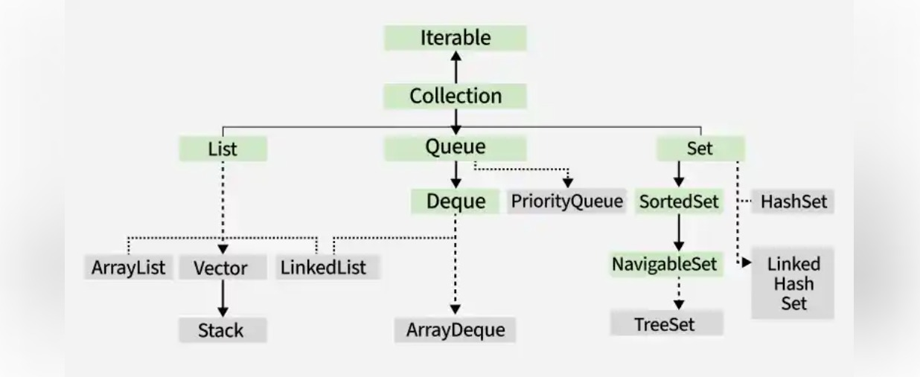

Features Of Collection Framework :
- Provide ready to use data structure
- Offer interfaces(collection,list,set,math,queue)
- To divide standard behaviour
- Support dynamic resizing ,unlike to array with fixed size
- Include algorithroms
- Improves code reusabilities and performance
LIST:
Allow duplicate values
SET:
Does not allow duplicate values
ARRAY LIST :
Array list in java is a resizable array provided in java.util package unlike to normal arrays
Array list size can be grow or shrink Dynamically as element or ordered or removed
Elements can be indices similar to array
Duplicates are allowed, default size 10
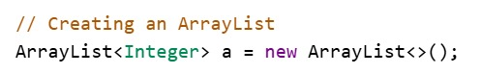

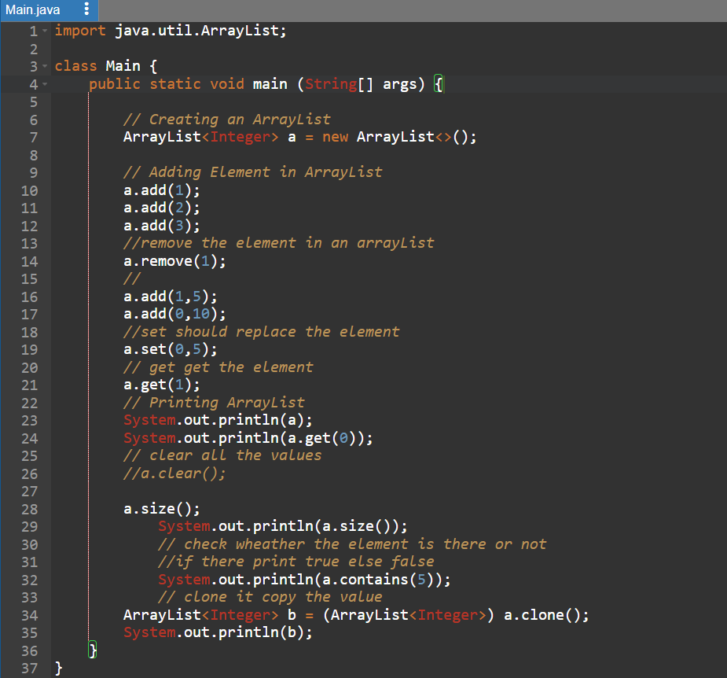

Output:
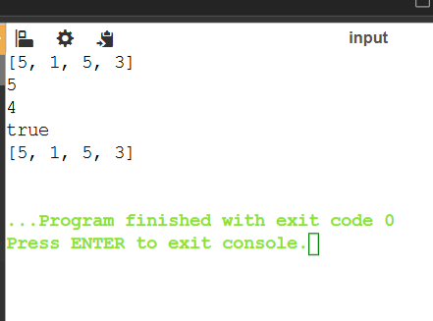

ARRAYLIST PROBLEM TO FIND SECOND LARGEST NUMBER

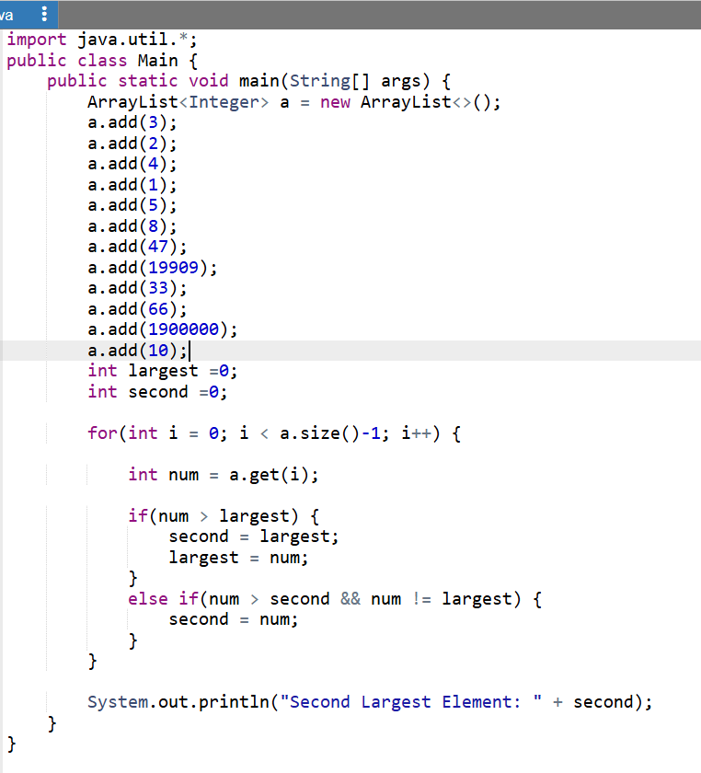

PATTERN PROBLEM

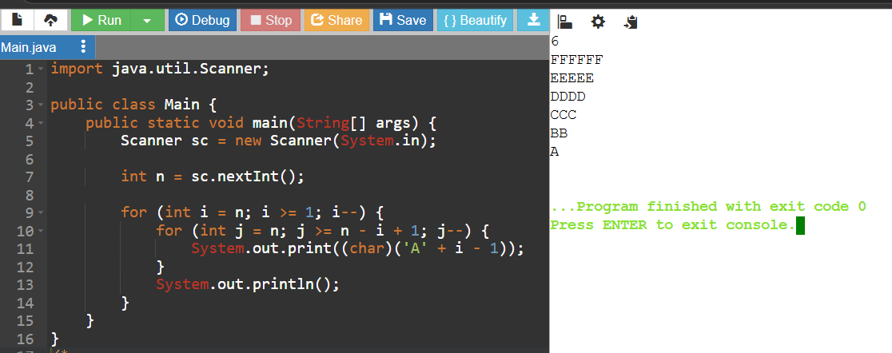

HASH MAP:
- HASH MAP IS A PART OF JAVA COLLECTION FRAMEWORK AND IMPLEMENT THE MAP INTERFACES IT STORE THE ELEMENT USE KEY VALUE PAIR WHERE KEY VALUES ARE UNIQUE
- INTERNALLY USE HASHING HENCE ALLOWS EFFICIENT KEY BASED ACCESS AND INSERT AND REMOVAL
- STORE THE VALUE WITH THE HELP OF KEYVALUE
- EVERY KEY VALUE SHOULD BE UNIQUE
- IT IS NOT A THREAD SPACE

- , DEFAULT SIZE 16
- THE CAPACITY OF HASHMAP IS THE NUMBER OF BUCKETS IT CAN HOLD FOR SHORTING ENTERIES
NEW CAPACITY = OLD CAPACITY * 2;

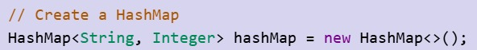

MOST IMPORTANT FUNCTION HASHMAP :
- MAP.GET - TO GET THE VALUES
Map.get(2);//key values
- MAP.CONTAINSKEY(KEY );
- MAP.CONTAINSVALUE(VALUE);
- MAP.REMOVE(KEY VALUE);
- MAP.SIZE(); - LENGTH OF WORD
- MAP.IsEmpty(); //create hashmap empty or not
- Map.keyset();
- Map.values();

FUTURE | ARRAY LIST | HASHMAP
STORAGE | SINGLE VALUE | KEY
PACKAGE | JAVA.UTIL.* | JAVA.UTIL.*
ACESS | INDEX | KEY VALUES
DUPLICATE VALUE | IT ALLOWED | IT ALLOWED
DUPLICATE KEY | KEY IS NOT APPLICABLE | KEY IS NOT ALLOWED
ORDER | INSERTION ORDER MAINTAIN | DOES NOT MAINTAIN
SEARCH | O(N) | O(1) AVERAGE
EXAMPLE | [1 ,2,3] | { 101 = IMTHI}
NULL KEY VALUE | NO KEY VALUES | ONLY ONCE IN HASHMAP

Sort an Arraylist
import java.util.*;
public class Main{
public static void main(String[] args) {
Scanner sc=new Scanner(System.in);
ArrayList<Integer> a=new ArrayList<>();
System.out.print("Enter 10 elements: ");
for(int i=0;i<10;i++)
a.add(sc.nextInt());
Collections.sort(a);
System.out.println("Sorted ArrayList: "+a);
}
}
Pattern Problem
import java.util.*;
public class Main {
public static void main(String[] args) {
Scanner sc = new Scanner(System.in);
int n = sc.nextInt();
char last = (char)('A' + n - 1);
for (int i = 0; i < n; i++) {
for (char j = last; j >= 'A' + i; j--) {
System.out.print(j);
}
System.out.println();
}
}
}

Empty subarray problem

import java.util.*;
public class Main {
public static void main(String[] args) {
Scanner sc = new Scanner(System.in);
int n = sc.nextInt();
int[] arr = new int[n];
for (int i = 0; i < n; i++) {
arr[i] = sc.nextInt();
}
int count = 0;
for (int i = 0; i < n; i++) {
int sum = 0;
for (int j = i; j < n; j++) {
sum = sum + arr[j];
if (sum == 0) {
count++;
}
}
}
System.out.println(count);
}
}
PATTERN PROBLEM
import java.util.*;
public class Main{
public static void main(String[] args) {
Scanner sc=new Scanner(System.in);
int n=sc.nextInt();
for(int i=0;i<n;i++){
char l=(char)('A'+n-(i+1));
for(int j=(n-1);j>=i;j--)
System.out.print((char)(l)+" ");
System.out.println();
}
}
}
PATTERN PROBLEM
import java.util.*;
public class Main{
public static void main(String[] args) {
Scanner sc=new Scanner(System.in);
int n=sc.nextInt();
int x=4;
for(int i=0;i<5;i++){
char l=(char)('A'+x);
for(int j=(n-1);j>=i;j--)
System.out.print((char)(l)+" ");
x--;
System.out.println();
}
}
}
PATTERN PROBLEM
import java.util.*;
public class Main
{
public static void main(String[] args) {
Scanner sc = new Scanner(System.in);
int n = sc.nextInt();
for (int i = n - 1; i >= 0; i--) {
for (int j = 1; j <= i; j++)
System.out.print("b");
for (int j = 2; j <= 2 * (n-i); j++)
System.out.print("*");
for (int j = 1; j <= i; j++)
System.out.print("b");
System.out.println();

}
}
}
Menu list for Biryani Juice Desserts
import java.util.*;
public class Main
{
public static void main(String[] args) {
Scanner sc = new Scanner(System.in);
System.out.println("Welcome to Thaj Hotel\nCustomer is our family, We serve with passion and LOVEEEEEE!\nDishes we make!");
System.out.println("1. Biriyani served with love");
System.out.println("2. Juice made with affection");
System.out.println("3. Dessert crafted with perfection");
System.out.println("4. Today's Special");
System.out.println("5. Exit");
String s = sc.next().toLowerCase();
if(s.equals("biriyani")||s.equals("1")){
System.out.printf("Chicken Biriyani \t\t Rs.100\n");
System.out.printf("Mutton Biriyani \t\t Rs.150\n");
System.out.printf("Prawn Biriyani \t\t Rs.170\n");
System.out.printf("Prawn Biriyani \t\t Rs.170\n");
System.out.printf("Veg Biriyani \t\t Rs.70\n");
System.out.printf("Exit");
int a[]={100,150,170,170,70};
}
else if(s.equals("juice")||s.equals("2")){
System.out.printf("Watermelon Juice \t\t Rs.40\n");
System.out.printf("Apple Juice \t\t Rs.50\n");
System.out.printf("Orange Juice \t\t Rs.40\n");
System.out.printf("Lemon Jucie \t\t Rs.30\n");
System.out.printf("Soda \t\t Rs.50\n");
}
else if(s.equals("dessert")||s.equals("3")){
System.out.printf("Ice-cream \t\t Rs.50\n");
System.out.printf("Milk-shake \t\t Rs.60\n");
System.out.printf("Waffle \t\t Rs.100\n");
System.out.printf("Kunafa \t\t Rs.200\n");
System.out.printf("Cheese Cake \t\t Rs.70\n");
System.out.printf("Brownie \t\t Rs.50\n");
}
else if(s.equals("exit")||s.equals("5")){
System.out.println("Thank you we expect you to visit again");
}
else{
System.out.println("Not Available");
}
}
}

